The ICOMOS Culture-Nature Prize
Supporting culture-nature initiatives led by ICOMOS members

This application form should be sent by 16 June 2024 23:59 CET to: culturenature[at]icomos.org

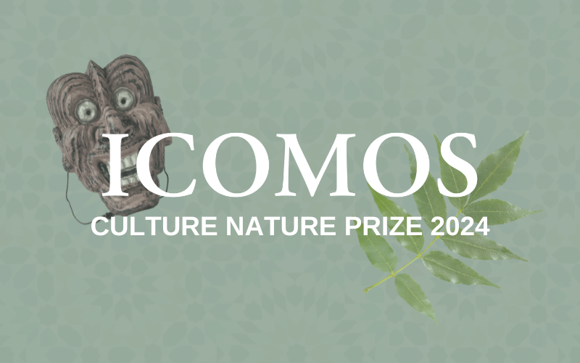

About the ICOMOS Culture-Nature Prize

ICOMOS is launching the 2nd edition of the ICOMOS Culture-Nature Prize, which will be awarded to support the most promising Culture-Nature initiatives undertaken by ICOMOS members.

Culture-Nature initiatives recognise the interconnections between cultural and natural heritage and rethink how we can protect culture and nature through a comprehensive approach with local communities. Through integrated protection, management and sustainable development of our heritage places, Culture-Nature initiatives build resilience to today’s challenges of climate change, pollution and rapid urbanisation.

The prize will be given to a project under implementation, which addresses connections between culture and nature and makes a significant contribution to the heritage field in an innovative and effective way.

ICOMOS members, Committees and Working Groups are eligible to apply.

Entries can be related to tangible or intangible heritage. Their scope can be ranging from small to large, from local to international.

The ICOMOS Culture-Nature Prize will honour up to 5 outstanding heritage initiatives.

The total prize money to be distributed to the winner(s) is 15.000€ (fifteen thousand euros). The jury will award the prizes to multiple winners, and the amount each winner receives will depend on the number and the quality of entries received.

The Prize winner(s) will be announced in September 2024.

For more information: culturenature[at]icomos.org

PART 1 Title and Summary

- Title of the Application
(Provide a short title of the project in 1 line maximum.)

- Summary of the Application
(Describe the project in 100 words maximum.)

- Where is the project implemented?

City/Community

Region

Country

PART 2 Applicant Details

- Contact Details (of the individual submitting the application)

Name (title, first name, surname)
Function

Organisation

Address

Telephone

Mobile phone

Email

Website

ICOMOS Committee
ICOMOS Membership Number

- Project Manager (if not the individual submitting the application)

Name (title, first name, surname)
Function

Organisation

Address

Telephone

Email

Website

ICOMOS Committee
ICOMOS Membership Number

PART 3 Additional Information

- Briefly describe the aims and content of the project. How does it address connections between culture and nature and make a significant contribution to the heritage field? (150 words maximum)

- Who are the partners involved in the project? (75 words maximum)

- How does your project engage with local communities? How do you work with them to implement the project? (100 words maximum)

- Briefly describe the project plan, management structure and timeline in place to implement your project. (300 words maximum)

- Indicate your current sources of funding, your annual operating expenses and any budgetary constraints. Please state figures in EUR. (200 words maximum)

- Briefly describe your plans for the project and how the prize money would be used to advance the project. Please provide a simple budget and state figures in EUR. (100 words maximum)

- How is your project innovative? (75 words max)

- Has the project been implemented or will it be implemented in other locations by you or another organization? (50 words max)

- Briefly explain the currents and future impact(s) of your project. (100 words max)

- How would the ICOMOS Culture-Nature Prize contribute to the project’s implementation and achievements? (75 words max)

PART 4 Supporting Materials

Please submit the requested materials as attachments to your email submission of this application form to culturenature[at]icomos.org

- Please submit at least 3 photographs of the project. All photos should be good quality (e.g. 300 dpi), in colour, clearly captioned and copyright free. (10 photographs maximum)

- Please share links to any articles published in the media about the project. (3 links maximum)

- Please provide links to any social media accounts dedicated to the project.

Awards Criteria

The Jury will assess the quality of applications according to the following criteria:

a) impact
b) community engagement
c) innovation.

If you have any questions on the application process, please write to culturenature[at]icomos.org

